
GRIDNODE PTE LTD

TRANSACTION MONITORING
REPORT GENERATION
Building Report Guide

Release version 1.0

Revision History

Revision | Date | Name | Comments
1 | 27 April 2007 | Regina Zeng | Initial creation
2 | 30 April 2007 | Regina Zeng | Draft 1
3 | 09 May 2007 | Regina Zeng | QA update

TRANSACTION MONITORING REPORT GENERATION
Building Report Guide

Contents

Chapter Page

Revision History 2
1 About the Guide 2
1.1 Related Websites 2
2 Tools Requirement 2
2.1 Installation of Report Designer 2
3 Overview of Transaction Monitoring Report Generation 3
3.1 Database 3
3.2 JasperReports 3
3.3 Report Interpretation 4
3.4 Report Parameters 5
4 Getting Started with iReport 6
4.1 Creating New Reports and Modifying Existing Templates 6
4.1.1 Sub Report Template 6
4.1.2 Main Report Template 7
4.1.3 Integrated Report Template 8
5 Appendix 11
5.1 Appendix A 11

About the Guide

This Transaction Monitoring Report Generation – Building Report guide is especially designed for the system administrator. The guide contains the instructions to perform a basic report creation in Transaction Monitoring application as well as modifying the existing report templates.

System administrator should be equipped with some basic knowledge of Oracle database query.

Related Websites

The following websites directly support Transaction Monitoring Report Generation:

- http://www.jaspersoft.com/JasperSoft_iReport.html
- http://www.jaspersoft.com/JasperSoft_JasperReports.html

Tools Requirement

Before getting started in building a Transaction Monitoring Report, the following tool is required:

- Report Designer – iReport-Designer

This Report Designer tool is required to generate report from *.jrxml format to *.jasper format (*.jasper format is required for generation of JasperReports).

While developing a report, you are able to build, test and run it locally, without publishing it to a report server. It can use the same processing and rendering extensions that the server uses, ensuring that users see the report as it was intended when they run it from the server.

Installation of Report Designer

Step 1: Click on the link below and select the latest iReport version.
For example, iReport-x.x.x.zip.

http://sourceforge.net/project/showfiles.php?group_id=64348&package_id=64215

Step 2: Proceed to follow the instructions from the website.

Overview of Transaction Monitoring Report Generation

There are 2 sets of report types supported by the Transaction Monitoring application currently – the Transaction Status Report and the Certificate Status Report. Each set is made up of the following 3 components:

- Sub Report Template
- Main Report Template
- Integrated Report Template

All modification of report templates should be stored back to the original directory. Any other directory might cause an inconsistency in Report Generation. Thus, all newly created report templates should be stored in the same directory as the Certificate Status Report templates and the Transaction Status Report templates.

Any new set of report templates should be build base on the Transaction Status Report templates. This will make the development easier.

Database

Transaction Monitoring Report Generation uses all the tables from both GTVAN schema and USERDB schema. Therefore, you are able to retrieve records from either schema.

The table below shows the corresponding naming convention to take note of during building of any reports.

Report Type | Template Name | Data Source Type  (Database Schema)
Transaction Status Report | TransactionStatusTemplate | 1
Certificate Status Report | CertificateStatusTemplate | 2

Report Type column shows the exact report type displayed in the User Interface of Transaction Monitoring application.

Template Name column shows the report template name without any file extension. This is used during developing of report templates. Noted that all template names should end with ***Template.

Data Source Type column shows the type of data source required during generating of a report. Note that there are only 2 type of data source available at the moment.

- Data Source 1 refers to GTVAN schema
- Data Source 2 refers to USERDB schema

For any creation of a new set of template, the respective database table has to be updated. (Refer to Appendix A).

JasperReports
JasperReports' reports are defined in XML files, which by convention have an extension of jrxml. A typical jrxml file contains the following elements:
- <jasperReport> - the root element.
- <title> - its contents are printed only once at the beginning of the report
- <pageHeader> - its contents are printed at the beginning of every page in the report.
- <detail> - contains the body of the report.
- <pageFooter> - its contents are printed at the bottom of every page in the report.
- <band> - defines a report section, all of the above elements contain a band element as its only child element.
For more information regarding JasperReports, please refer to the related websites provided in the Related Website of this guide.

Report Interpretation
Title Logo

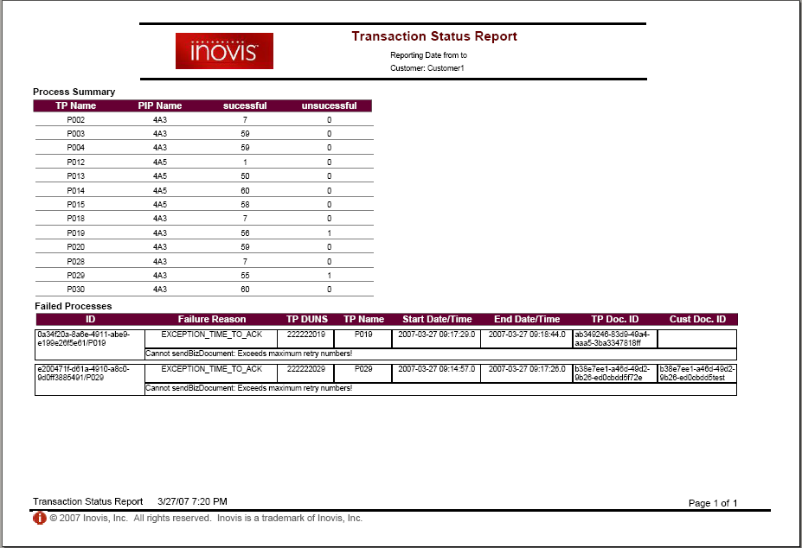
Main Report Template
Sub Report Template
Report Name
Report Name
Report Variables

Small Logo

The above figure shows a report preview.

Title Logo
This is the Inovis logo.

Small Logo
This is the smaller version of Inovis logo.

Report Name
This name refers to the selected report type to be generated by the end user of the Transaction Monitoring application.

Report Variables
These variables are the variables passed as parameters from the Transaction Monitoring application to the report generation tool (iReport). These variables are optional.

Main Report Template
This template identifies a summary data of the report.

Sub Report Template
This template identifies a more focus data base on the summary data of the report.

Report Parameters

The Transaction Monitoring application passes 8 parameters to the report generation tools (iReport). The parameters include:
- SUBREPORT_DIR:
This parameter identifies the directory where both Sub Report Template and Main Report Template .jasper are stored.
Example: “C:/iReport-1.3.1/”.
- REPORT_TIME_ZONE
This parameter identifies the TimeZone object itself being passed as parameter. Note that this parameter is not editable in iReport. iReport uses its default TimeZone – system TimeZone.
- customer_name
This parameter identifies the customer whom the end user had selected for the report generation.
- start_time
This parameter identifies the starting date/time range of the report.
- end_time
This parameter identifies the ending date/time range of the report.

- image_dir
This parameter identifies the directory where the image_title and image_smallLogo are stored.
Example: “C:/images/”.

Note: The image directory in the actual report server is pointing to the Transaction Monitoring User Interface image directory. Currently, it is known to be: “JBOSS_HOME/server/default/deploy/txmr.war/image/”.

- image_title
This parameter identifies the file name of the title logo.
Example: “logo.jpg”.

- image_smallLogo
This parameter identifies the file name of the small logo.
These parameters’ names are case sensitive.

Getting Started with iReport

The Report Designer used in the Transaction Monitoring application is iReport-1.3.1.

After installing iReport as stated in Tools Requirement of this guide, go to the root folder where iReport is installed and click on the  iReport.exe application.

For more information regarding iReport designer, please refer to the related websites provided in the Related Website of this guide.

Note: Make sure ojdbc14_g.jar or any supporting .jar files are available in iReport-x.x.x/lib folder.

Creating New Reports and Modifying Existing Templates

As mentioned earlier, the Transaction Monitoring Report is made up of 3 components. The following pointers will show how to build a report. Creating new reports and modifying existing templates has the similar procedures. Only thing to note is that modifying existing templates should omit all Step 2 and Step 3.

Reports should be created or modified accordingly with the sequence Sub Report Template, Main Report Template followed by Integrated Report Template.

Sub Report Template

There are 6 components to be changed base on the TransactionStatusTemplateSub.jrxml.

- Report name
- Database query statement
- Page Header Band of report
- Page Header band of report if no data retrieved from database (optional)
- Column Header Band of report
- Detail Band of report

Step 1: Select File > Open > TransactionStatusTemplateSub.jrxml.

Step 2: Select File > Save As. Create a new report template name.
(i.e. ***StatusTemplateSub.jrxml).

Step 3: Select Edit > Report Properties > Change the Report Name.
(i.e. ***StatusTemplateSub).

Step 4: Select Data > Report Query > Insert the SQL query in the given white space.

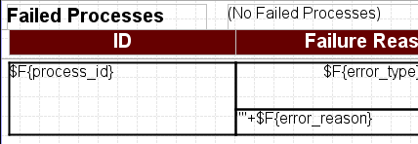
Page Header Band
Column Header Band
Detail Band

Step 5: Double click on the Text Box with “Failed Processes” and change it to your desired value.

Step 6: Right click on the Text Box with “(No Failed Processes)” > Properties >
Column tab > Print when expression > Open the expression editor.

Step 7: Highlight the portion in green and replace it with the unique field shown in the Objects and expressions column. (i.e. “No Failed Processes” will be printed if “process_id” is null).

Step 8: Update all the column names in the Column Header Band

Step 9: Update all the fields in the Detail Band.

Step 10: You may wish to re-design your own layout, but bear in mind to keep every component inside the page margin. Any components found outside the page margin boundary will be boxed in red, which alerts you to follow the rules.

Step 11: Upon completion of the template, select Build > JRViewer Preview

Step 12: Select Build > Compile ( ).

Step 13: Select Build > Execute (with active connection) ( ).

Step 14: Check if the generated report is the desired one.

Main Report Template

There are 6 components to be changed base on the TransactionStatusTemplateMain.jrxml.

- Report name
- Database query statement
- Page Header Band of report
- Page Header Band of report if no data retrieved from database (optional)
- Column Header Band of report
- Detail Band of report

Step 1: Select File > Open > TransactionStatusTemplateMain.jrxml.

Step 2: Select File > Save As. Create a new report template name.
(i.e. ***StatusTemplateMain.jrxml).

Step 3: Select Edit > Report Properties > Change the Report Name.
(i.e. ***StatusTemplateMain).

Step 4: Select Data > Report Query > Insert the SQL query in the given white space.

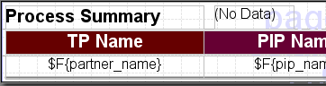
Page Header Band
Column Header Band
Detail Band

Step 5: Double click on the Text Box with “No Data” and change it to your desired value.

Step 6: Right click on the Text Box with “(No Data” > Properties > Column tab > Print when expression > Open the expression editor.

Step 7: Highlight the portion in green and replace it with the unique field shown in the Objects and expressions column. (i.e. “No Data” will be printed if “partner_name” is null).

Step 8: Update all the column names in the Column Header Band

Step 9: Update all the fields in the Detail Band.

Step 10: You may wish to re-design your own layout, but bear in mind to keep every component inside the page margin. Any components found outside the page margin boundary will be boxed in red, which alerts you to follow the rules.

Step 11: Upon completion of the template, select Build > JRViewer Preview

Step 12: Select Build > Compile ( ).

Step 13: Select Build > Execute (with active connection) ( ).

Step 14: Check if the generated report is the desired one.

Integrated Report Template

There are 8 components to be changed base on the TransactionStatusTemplate.jrxml.

- Report name
- Database query statement (returning a unique row)
- Title Band of report showing the report name
- Title Band of report showing the Report Variables
- Page Header Band of report if no data retrieved from database (optional)
- Detail Band of report with Main Report Template
- Detail Band of report with Sub Report Template
- Page Footer Band of report showing the report name

Step 1: Select File > Open > TransactionStatusTemplate.jrxml.

Step 2: Select File > Save As. Create a new report template name.
(i.e. ***StatusTemplate.jrxml).

Step 3: Select Edit > Report Properties > Change the Report Name.
(i.e. ***StatusTemplate).

Step 4: Select Data > Report Query > Insert the SQL query in the given white space.

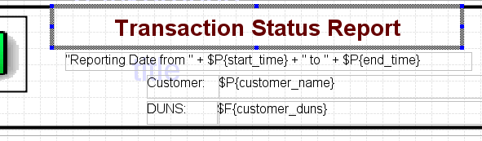

Step 5: Double click on the Text Box with “Transaction Status Report” and change it to your desired value.

Step 6: Right click on the Text Box with “Reporting Date from…” > Properties >
Text Field tab > Text Field Expression > Open the expression editor.

This is to make any changes to the Report Variables.

Step 7: Right click at any empty space in the Page Header Band > Band Properties > Print When express > Open the expression editor.

Step 8: Highlight the portion in green and replace it with the unique field shown in the Objects and expressions column. (i.e. will be printed if “customer_duns” is null).

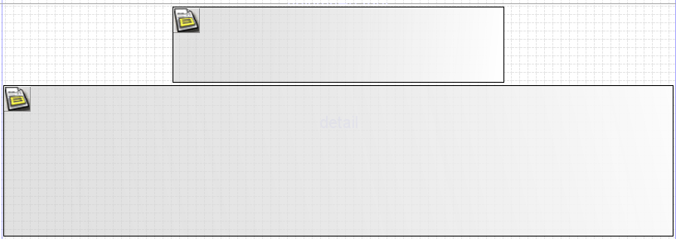
Main Subreport
Sub Subreport

Step 9: Right click at any space in the Main Subreport > Properties > Subreport (Other) > Subreport Expression > Open the expression editor > replace “TransactionStatusTemplateMain.jasper” with your Main Template .jasper.

Step 10: Right click at any space in the Sub Subreport > Properties > Subreport (Other) > Subreport Expression > Open the expression editor > replace “TransactionStatusTemplateSub.jasper” with your Sub Template .jasper.

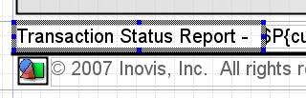

Step 11: Double click on the Text Box with “Transaction Status Report” and change it to your desired value.

Step 12: Make sure that all Report Parameters are validated against those mentioned in Report Parameters.

Step 13: You may wish to re-design your own layout, but bear in mind to keep every component inside the page margin. Any components found outside the page margin boundary will be boxed in red, which alerts you to follow the rules.
Step 14: Upon completion of the template, select Build > JRViewer Preview

Step 15: Select Build > Compile ( ).

Step 16: Select Build > Execute (with active connection) ( ).

Step 17: Check if the generated report is the desired one.

Appendix

Appendix A

Sample of existing set of Report Templates using Oracle Database – Transaction Status Report

The templates should be created using iReport and name after the following:
- TransactionStatusTemplateSub.jrxml
- TransactionStatusTemplateMain.jrxml
- TransactionStatusTemplate.jrxml

The GTVAN schema should be updated with the following statement:

INSERT INTO “GTVAN”.“rpt_report_type” (“uid”, “version”, “report_type”, “template_name”)
VALUES (‘fd563136-d907-4cb3-9544-d405a2dd6764’, 0, ‘Transaction Status Report’, ‘TransactionStatusTemplate’);

The database query for TransactionStatusTemplateSub.jrxml:

SELECT
"process_id",
"error_reason",
"error_type",
"partner_duns",
"partner_name",
"process_start_time",
"process_end_time",
"request_doc_no",
"response_doc_no",
"process_status"
FROM
"isat_process_transaction"
WHERE
"customer_name" = $P{customer_name}
and to_char("process_end_time",'mm/dd/yyyy hh24:mi:ss') >= $P{start_time}
and to_char("process_end_time",'mm/dd/yyyy hh24:mi:ss') <= $P{end_time}
and "is_process_success" = 0
and "process_end_time" IS NOT null
ORDER BY
"partner_name" ASC,
"process_start_time" ASC;

The database query for TransactionStatusTemplateMain.jrxml:

Select
"partner_name","pip_name", "customer_name", "customer_duns", sum("successful") as "successful" ,sum("unsuccessful") as "unsuccessful" from
(
Select "partner_name","pip_name", "customer_name", "customer_duns", 1 as "successful",0 as "unsuccessful" from "isat_process_transaction"
where "is_process_success"= 1
and "process_end_time" is not null
and "customer_name"=$P{customer_name}
and to_char("process_end_time",'MM/dd/yyyy hh24:mi:ss') >=$P{start_time}
and to_char("process_end_time",'MM/dd/yyyy hh24:mi:ss') <=$P{end_time}
UNION ALL
Select "partner_name","pip_name", "customer_name", "customer_duns", 0 as "successful",1 as "unsuccessful" from "isat_process_transaction"
where "is_process_success"= 0
and "process_end_time" is not null
and "customer_name"=$P{customer_name}
and to_char("process_end_time",'MM/dd/yyyy hh24:mi:ss') >=$P{start_time}
and to_char("process_end_time",'MM/dd/yyyy hh24:mi:ss') <=$P{end_time}
)
temp group by "partner_name","pip_name", "customer_name", "customer_duns" order by "partner_name","pip_name";

The database query for TransactionStatusTemplate.jrxml:

Select distinct "customer_duns" from "isat_process_transaction"
where "customer_name" = $P{customer_name}

